PE STUDIES Revision Notes - Exercise Physiology

Environmental Conditions and Performance:

* Different conditions will affect performance
  + - Temperature- hot/cold
    - Humidity- dry/wet
    - Altitude/Sea Level

Temperature Regulation:

* **Heat gain**
  + - Basal metabolic rate
    - Hormones
    - Environment
    - Muscular activity
* **Heat loss**
  + - Conduction:

Heat exchange by two objects in contact

Factors affecting:

Surface area

Difference in temperature between surfaces

Thermal conductivity of material

Plays very small role in heat loss e.g. Wearing ice vest

* + - Convection:

Heat exchange by contact with fluid.

Will occur when heat is carried away from the body by air or water currents

Fast air flow= heat loss high, air is continually displaced

Slow air flow= heat loss low, air is not moved

Most effective when temperature of air/water around body is low

Accounts for about 12% of heat loss

* + - Radiation:

Occurs when heat from a warmer body is transferred to its cooler surroundings

Accounts for about 60% heat loss on a cool day

When ambient temperature exceeds body temperature, it acts as heat gain method

* + - Evaporation:

The cooling of the body as a result of vaporisation of sweat from the skin

Heat is transferred to the skin surface via blood, and released as sweat

Increased blood flow to skin is a result of vasodilation

Cooling effect comes from evaporation of sweat from skin, as a result the cooler blood cools the body

Accounts for 25% heat loss at rest, up to 80% in hot conditions

Rate of sweating is dependent on: gender, age, physical fitness

* Body's preferred method of heat loss is dependent on 3 things;
  + - **Environment**:

Ambient temperature- if above core temperature, evaporation is only form of heat loss

Forced Convection- if windy convection is used

Barriers to Convection- clothing will minimise effect of convection

Relative Humidity- higher it is, less likely evaporation will work

* + - **Age**:

Children sweat less than adults as their sweat glands are not properly developed

* + - **Physiological State:**

Rate of heat production

Hydration state- reduction in blood plasma (water) results in decreased sweat rate

**Dehydration:**

* Occurs when the amount of water leaving the body exceeds the amount that you are taking in
* We lose water by
  + - Sweating
    - Breathing
    - Urinating
* Can cause- dizziness, headache, fatigue, nausea
* Heat Exhaustion- dehydration as well as an ineffective circulatory system
* Heat Stroke- severe dehydration

**Rest and Exercise in the heat**;

* At rest, the bodies heart rate and cardiac output increase
* When exercising the body experiences Double Heat Load:
  + - Producing heat from muscular activity
    - Environmental temperature is above core temperature
    - Double heat load creates competition for blood flow
      * + Muscles and vital organs require blood flow to sustain energy and metabolic action
        + Skin requires blood to remove heat from the body

**Cardiac Drift:**

* When exercising in the heat the body directs blood flow to the skin to increase Evaporation
* An Increase in Sweat Rate results in a Decrease of Blood Plasma Volume
* As a result, Cardiovascular Drift occurs
* Stroke Volume Decreases as a result of a decreased blood plasma volume
* In an attempt to maintain cardiac output, Heart Rate Increases
* Increase in heart rate is relatively smaller then the increase in stroke volume, therefore Cardiac Output is Reduced
* As a result, blood flow to skin and muscles decreases, placing extra strain on body to perform
* A build up of Lactic Acid in the muscles and a Reduced Sweat Rate
* These changes lead to an increased core body temperature and an inhibited performance

Methods to Cope with Exercising in Heat:

* **Hyper-hydrate**
  + - Consume 300-400ml just before performance and 600ml 3-4 hours before
    - Avoid diuretics as they promote urination, e.g. caffeine
* **Consume 150-200ml every 15 minutes during performance**
* **Wear loose fitting, light coloured clothing**
  + - This promotes heat loss via convection and evaporation
* **Pre-Cool core body temperature** 
  + - Ice vests, immersion in cold water, Slushies
* **Acclimatise**
* **Post exercise consume 1.5x amount lost in fluids** 
  + - This accounts for urination
    - Consume slightly salty fluid to keep osmolality high, preventing urination

**Hyponatremia**:

* An abnormally low concentration of sodium in the blood
* Occurs when you are sweating but replacing only with water, leaving a lack of salts
* It can interfere with brain and muscle functioning
* Sports drinks assist
  + - Contain carbohydrates, sodium and potassium
    - Effective because they: taste good, replace electrolytes, high GI

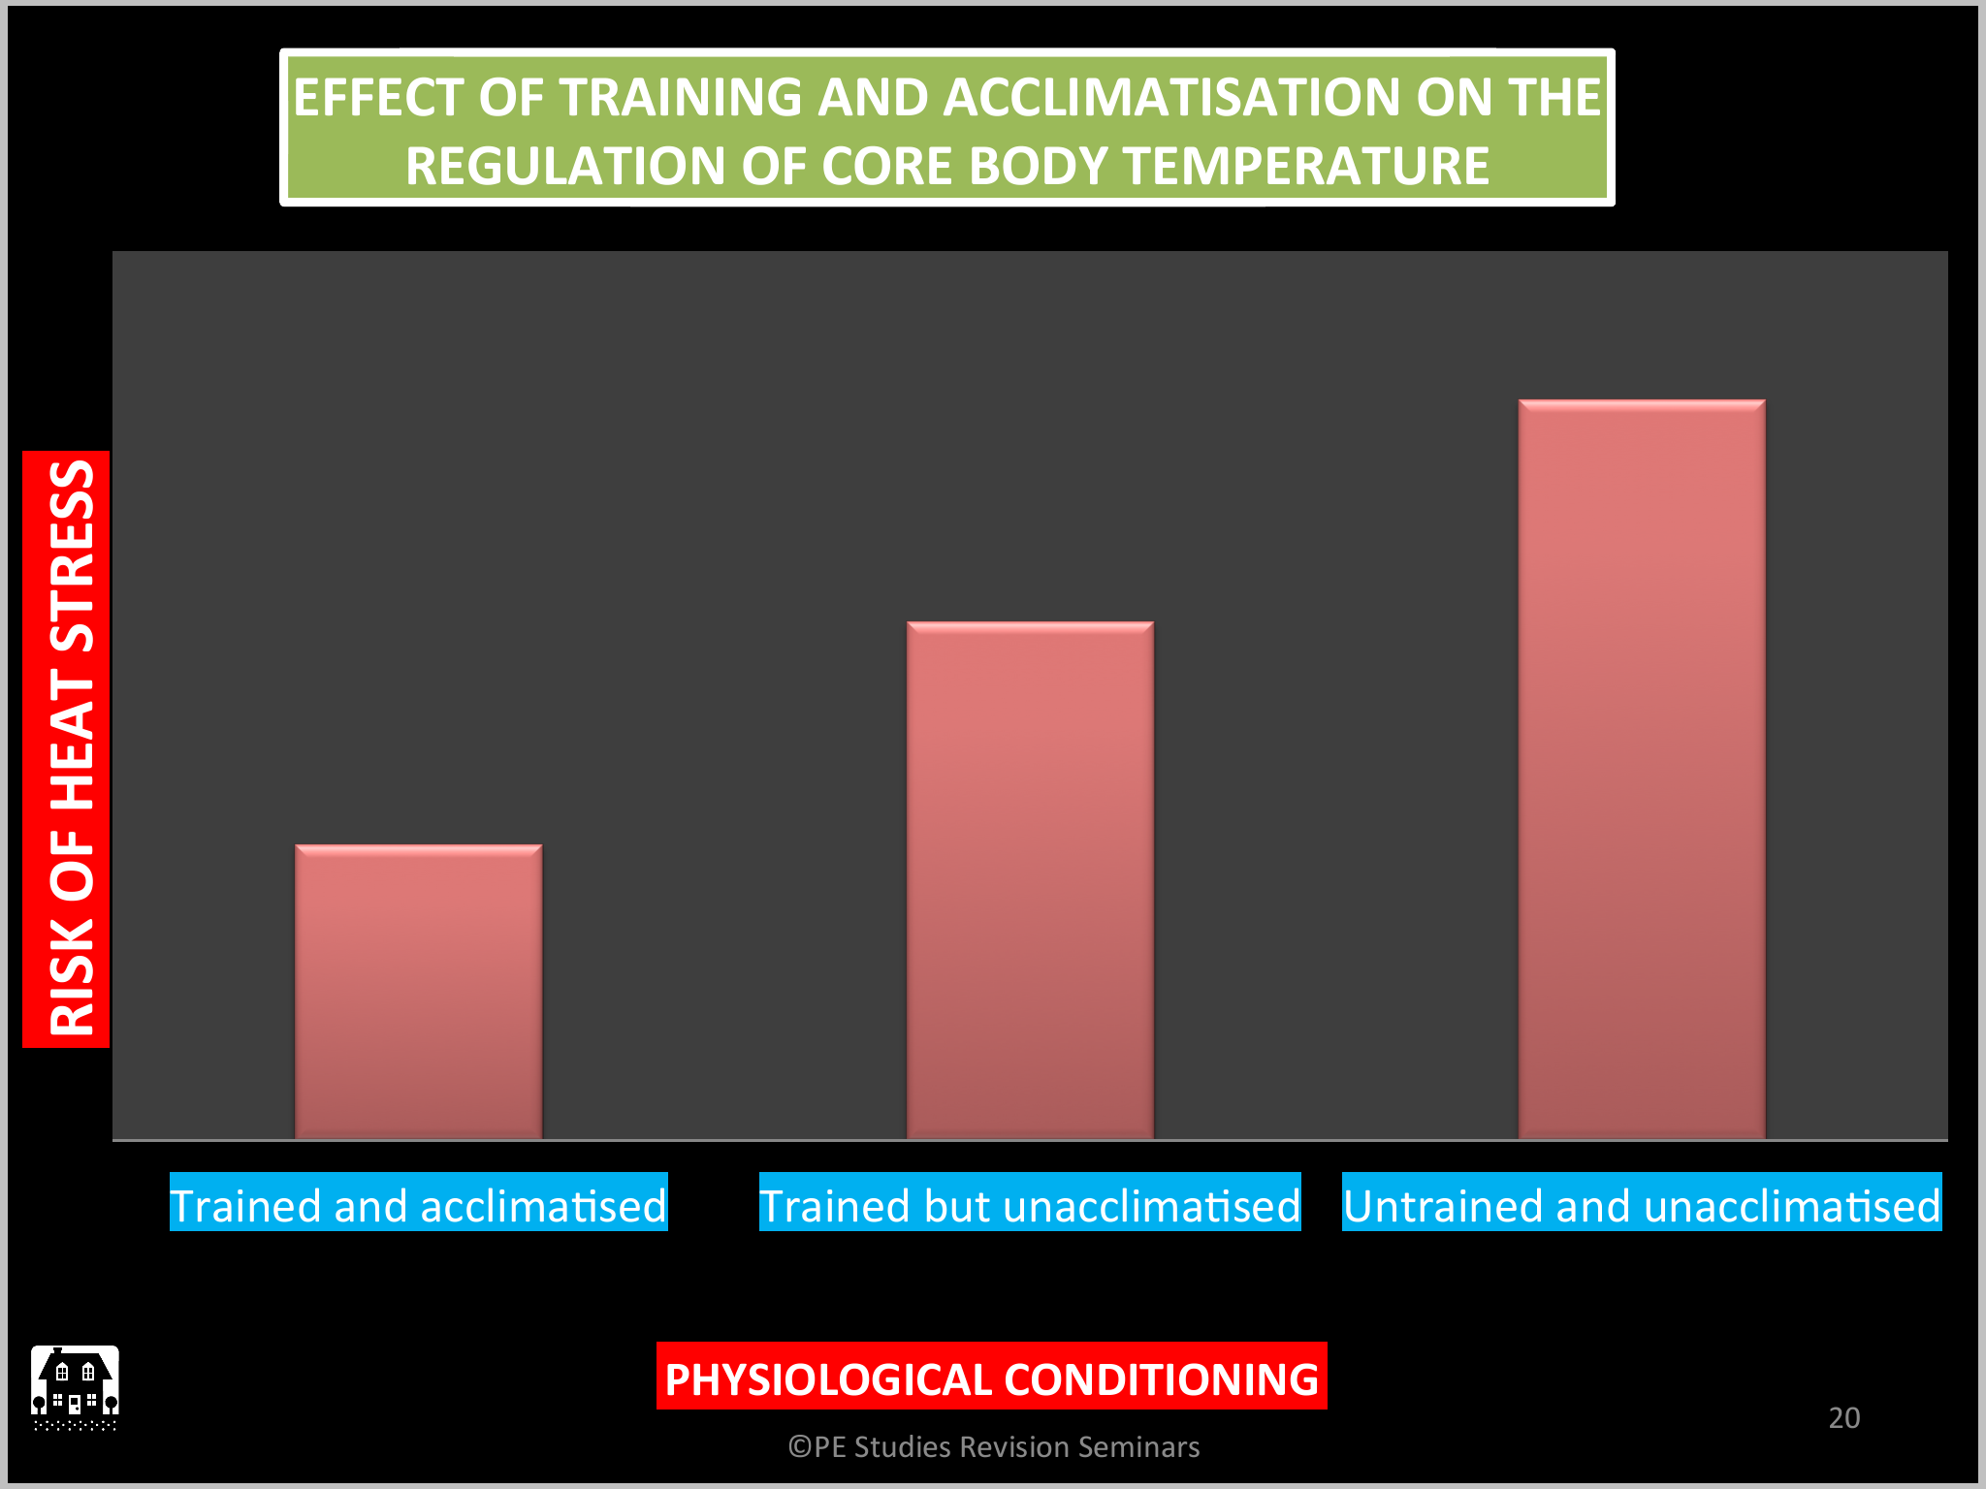

**Heat Acclimatisation:**

* When heat tolerance is improved by repeated exposure to hot environments
* Adequate hydration is required for optimal heat acclimatisation.
* How to acclimatise:
  + - 5-10 days living and training in hot environment
    - First session is short with light to moderate intensity, but as training regime continues, increase duration and intensity
    - Artificial Altitude alternatives can be used
      * + Altitude Chambers
        + Sweat clothing
        + Saunas
* Should be completed 4-6 weeks prior to competition, then 2x per week leading up to competition

Adaptions to Heat Acclimatisation:

* **Sweating Adaptions:**
  + - Increased sweat rate as a result of increased size of sweat glands
    - Start to sweat at a lower core body temperature (more blood sent to muscles)
    - Sweat becomes more dilute and is distributed over the body more, using greater surface area for evaporation
* **Cardiovascular Adaptions:**
  + - Exercise with lower core and skin temperature (due to sweating adaptions)
    - Heart rate is lower due to more effective cooling system
    - More blood sent to muscles during performance, rather then skin for heat loss

Exercise in Cold:

* It is easier to protect yourself from cold environments than hot environments
* Do this by wearing suitable clothing, however you still need to allow for evaporation to occur
* **Shivering**:
  + - Involuntary muscle contractions in response to chilling effect of cool temperature
* **Performance in the Cold:**
  + - Increased sub maximal VO2 at given exercise intensity
    - Fine motor skills deteriorate due to vasoconstriction
* **Risk of Dehydration:**
  + - Inhaled air is very cold and dry- needs to be warmed, therefore lots of water used in this process
    - 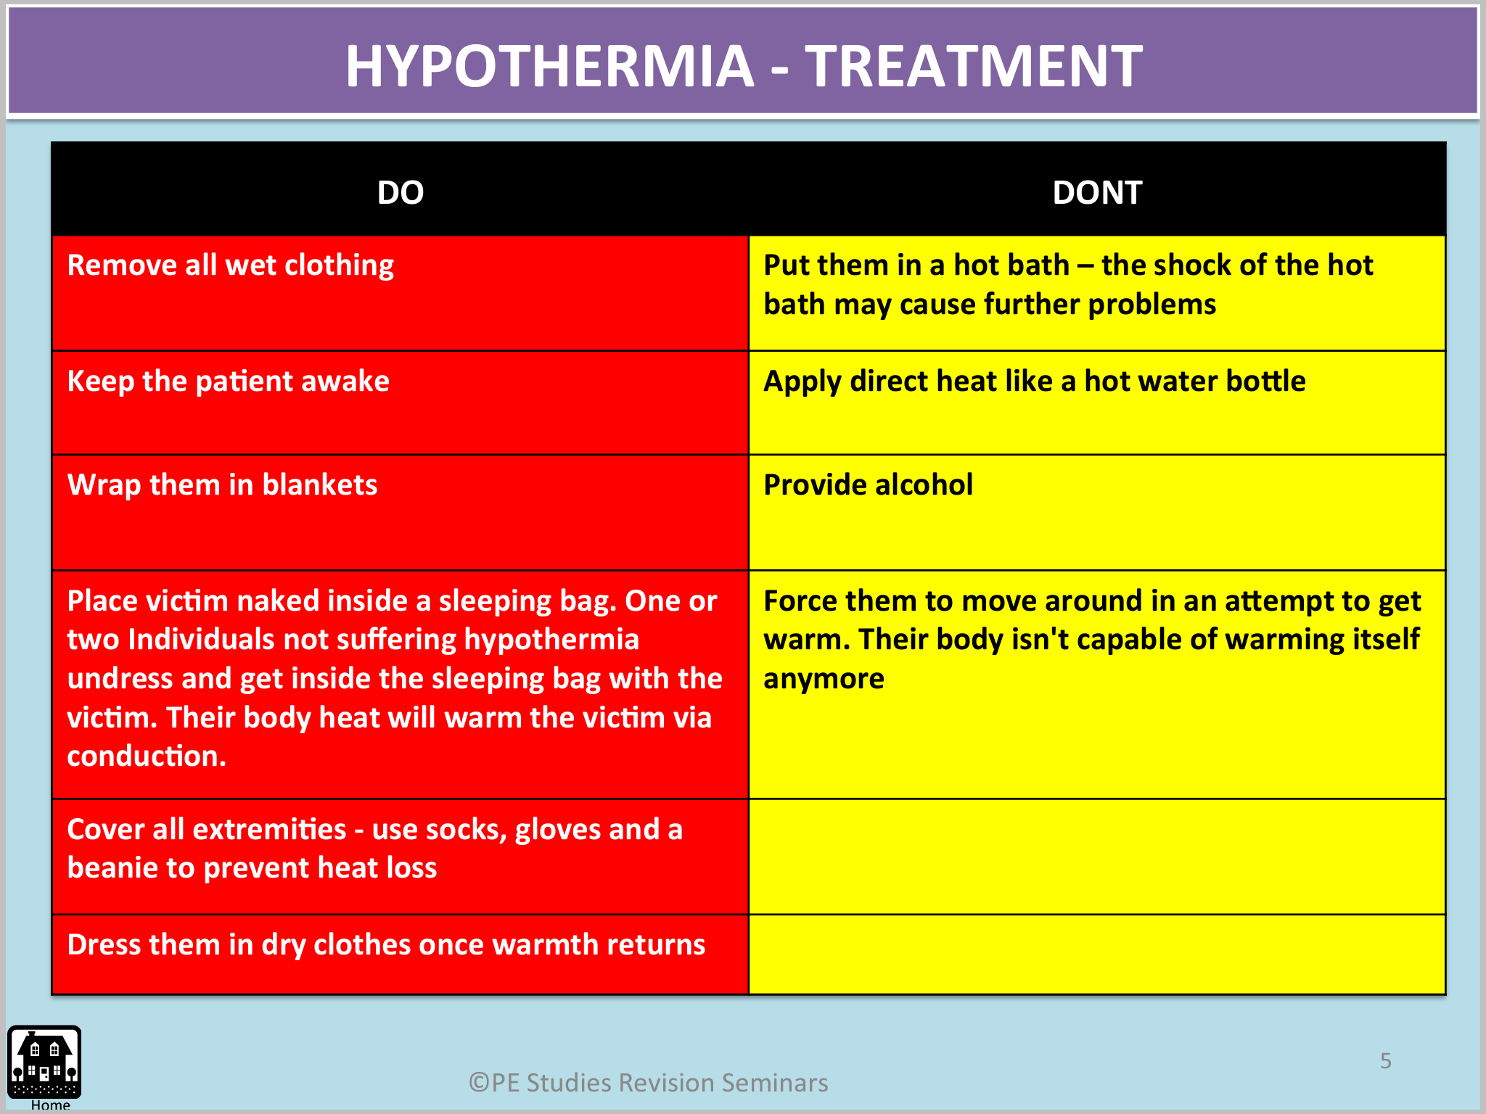Reduced sensation if thirst, increases likelihood of dehydration
* **Hypothermia:**
  + - Hypothermia is when the body temperature decreases to a level of less then 35 degrees
    - May occur via: prolonged exposure to cold, windy weather, cold water
    - Symptoms: shivering, slowed breathing, coma, feeling cold, death
* **Cold Acclimatisation:**
  + - Should be done 7-10 days prior to competition
    - No evidence to suggest that there are any physiological benefits, more of a psychological advantage

**Altitude**:

* Gas exchange takes place due to a pressure difference, called a Pressure Gradient
* At altitude there is a reduction of this pressure gradient

Altitude Acclimatisation:

* + - Describes the improved physiological response to altitude hypoxia
    - How to-
      * + Method 1: Artificial Altitude

Daily intermittent exposure to artificial altitude

Sleep in an artificial chamber whilst training under normal conditions

* + - * + Method 2: 'Live High Train Low.

This method allows you to maintain exercise intensity

Take altitude camps throughout year to gain benefits then maintain by training at sea level as normal

Requires about 3-4 weeks at altitude to gain benefits

Adaptions to Altitude Training

* **Acute**:
  + - Increased pulmonary ventilation, the body will attempt to hyperventilate to intake more oxygen
    - Increased cardiac output and heart rate during rest, to get more blood/oxygen circulating
    - Decreased blood plasma volume to increase concentration of haemoglobin in blood
* **Chronic**:
  + - Increased number of red blood cells in bone marrow, therefore increase in haemoglobin in the blood
    - Increase in mitochondria, capillaries and aerobic enzymes
    - Increase in diphosphoglycerate, assist with unloading of oxygen at tissue level
* Preparing for Competing at Altitude:
  + - Increase recovery time between sessions
    - Tapering period in the lead up is essential to allow athlete time to peak for competition
    - Fluid replacement regime
    - Decrease intensity of training prior to competition whilst at altitude

**Nutrition**:

* A balanced diet will contain the correct amount of macronutrients
  + - Carbohydrates (CHO), Fats/Lipids, Protein, vitamins, minerals, water
* By consuming these it ensures the body:
  + - Meets energy demands
    - Provides energy for metabolic function
    - Allows for growth and repair of tissue
* Factors effecting energy requirements: age, gender, level of physical activity
* When there is an increased load, it is important to increase CHO and protein consumption
* Protein:
  + - Growth and repair of muscle tissue
    - Production of red blood cells, hormones, antibodies
    - In extreme circumstances, when CHO and fats depleted, will contribute to energy production
* Fats/Lipids:
  + - Represents the body's most plentiful source of potential energy
    - Stored as Triglycerides in muscle cells and are broken down into free fatty acids
    - Major energy source of energy during rest and moderate exercise, little input with increased intensity
    - Slow to break down into energy
    - Can be used for glycogen sparing
* Carbohydrates:
  + - When ingested, converted to blood glucose, leading to increase in insulin levels
    - Excess blood glucose then converted to glycogen and stored in muscles and liver
    - Supplies energy during rest, moderate and high intensity exercise
    - Glycaemic Index-
      * + Ranking of foods based on how quickly they effect the body's blood glucose levels
        + Low GI:

Slow to break down, releasing glucose gradually into blood stream

Best consumed 1-4 hours pre event or after event

E.g. Apples, lentils, beans sausages

* + - * + Moderate GI:

Break down slightly faster and have a faster effect on the body's blood glucose levels

Best consumed as pre event or post event meal

E.g. Corn, peas, pasta, oranges

* + - * + High GI:

Quick to break down and have an immediate effect on blood glucose levels

Best consumed during or immediately after exercise

Assists with glycogen sparing

E.g. Glucose, honey, banana

* + - **Carbohydrate Loading:** 
      * + Is a nutritional intervention aimed at delaying the depletion of glycogen stores. It occurs when the athlete increases the amount of CHO consumed prior to competition with the aim being to store extra glycogen in the liver and muscles
        + As exercise increase, the amount of CHO used increases
        + Muscle and liver glycogen, and blood glucose can be used within 2 hours, so CHO loading assists with the prolonging of this
        + 2 main methods to load-

3 day method- consume large amount of CHO leading up to event, but significant tapering is required

1 day method- consume large amount of CHO the day before event, but reduce activity as to spare the stored glycogen

* + - * + Advantages-

Avoids glycogen depletion by increasing amount of glycogen in muscles and liver

Can maintain exercise at higher intensity for longer period of time

* + - * + Disadvantage-

Binding if water to CHO occurs, resulting in weight gain

**Rebound Hypoglycaemia;**

* When an athlete consumes High GI food just prior to an event, causing a rapid increase in blood glucose levels and an overshoot of insulin release
* This significantly reduces blood sugar levels, Impairing the functioning of CNS during exercise
* This results in a decreased performance

**Ergogenic Aids;**

* Any practice or substance, legal or illegal, used to improve performance.
* This may include legal practices such as the use of heart rate monitors or nutritional aids or illegal aids such as the use of anabolic steroids.
* 5 categories:
  + - Physiological- altitude training, acclimatisation
    - Psychological- imagery, relaxation techniques
    - Pharmacological- anabolic steroids
    - Mechanical- equipment, clothing
    - Nutritional- CHO loading, caffeine
* Creatine:
  + - A naturally occurring compound which is found on skeletal muscles
    - Advantages:
      * + Allows athletes to increase training volume and decrease recovery time
        + Improves ATP and Phosphocrearine resynthesis, increasing athletes biliary to produce repeated efforts
        + Increased amount of Phosphocrearine in muscle results in ATP/PC process to occur for longer without fatigue
    - Disadvantages:
      * + Feeling of cramping and gastrointestinal pain
        + Increase the storage of water in the muscles, rapid weight gain
* Caffeine:
  + - Best consumed just prior to performance
    - Advantages:
      * + Acts as an analgesic, reducing the perception of effort
        + Stimulates the CNS- more alert, more aroused, reaction time faster
        + Helps with isolation of fat as a fuel source, assisting with glycogen sparing (CHO)
    - Disadvantages
      * + Diuretic, Irritability, Insomnia, Headaches
* Anabolic Steroids:
  + - Increase the side and strength if the performer through the facilitation of muscle development and the improved rate of muscle repair
    - Beneficial in power sports as athletes can train more frequently with less rest time
    - Disadvantages
      * + Acne, Depression, Liver Damage, Infertility
* Stimulants:
  + - Increase awareness, aggression and masks fatigue, improving performance
    - Disadvantages
      * + Anxiety, restlessness, dependence, insomnia
* Blood Doping- Autologous
  + - Remove blood from your body and freeze it for storage
    - Over the following weeks lost red blood cells are resorted through secretion of Erythroprotein(EPO)
    - Prior to competition add the frozen blood, this will increase the number of red blood cells in the body, improving VO2 max
    - Risks- transfer of disease, heart failure, blood clots
    - Homologous- where blood is used from another person
* Erythroprotein: hormone found naturally in the body which assist with formation of red blood cells, increasing VO2 max

Recovery;

* Aims to return body to pre-exercise state and reverse the effects of fatiguing
* Efficient Recovery-
  + Enhances adaptions to exercise loads
  + Prepares performer for their next training or performance
* Insufficient Recovery-
  + Delays removal of fatiguing factors
  + Increases risk of overtraining or over use injuries
* Phosphocrearine(PCr) Store Recovery:
  + Begin to restore as soon as rest or recovery starts
  + Is facilitated by a passive recovery
  + The liver restores PCr stores from amino acids and from food intake
* Nutritional Recovery:
  + It is critical to restore used glycogen immediately after exercise as muscles are most sensitive
  + High GI foods should be eaten in the first 30-60 minutes, as well as fluid replacement
* Active Recovery
* Keeps blood being sent to muscles high, therefore O2 which assist with lacks acid removal
* Creates a Muscle Pump which increases O2 supply and waste removal. Massage can assist this
* Prevents Venous Pooling, a build up of blood in areas where it is hard for it to be removed
* Contrast Bathing can create a venous pump by alternating vasodilation and vasoconstriction

Training Principals (**S.P.O.R.T.F.I**);

* Specificity:
  + - Training needs to mimic  competition performance and meet the aims/goals of the individual undertaking the training program
      * Muscle group used
      * Fitness component used
      * Skills performed
      * Energy systems used
      * Intensity or speed of performance
* Progressive Overload:
  + - Should be increased gradual amounts
    - Generally only one variable is varied at one time
      * + Time/Duration: rest and work periods
        + Intensity: weight, speed, distance
        + Frequency: how often- per day/week, how often- per session
    - Progressive Overload is specific to each individual
* Reversibility:
  + - Gradual loss of beneficial training effects when the Frequency, Intensity or Duration are reduced
    - This must be accounted for when athletes return to training after a break.
* Time/Duration:
  + - Can refer to either the length of me of each training session, parts of the training session or the length of me for a training program
    - Exercise intensity is a limiting factor on the time/duration
* Frequency:
  + - The more frequent an athlete trains and the longer the training program, the greater the fitness benefits
    - The idea is not to train as often a possible, but to  find a balance between training and recovery
* Intensity:
  + - Refers to how hard each training session is, and it is usually measured as a percentage of maximum heart rate
    - Largest determination of how much adaption will result from a training program

Periodisation;

* The planning, well in advance, of training variables to achieve optimal performance at the most crucial times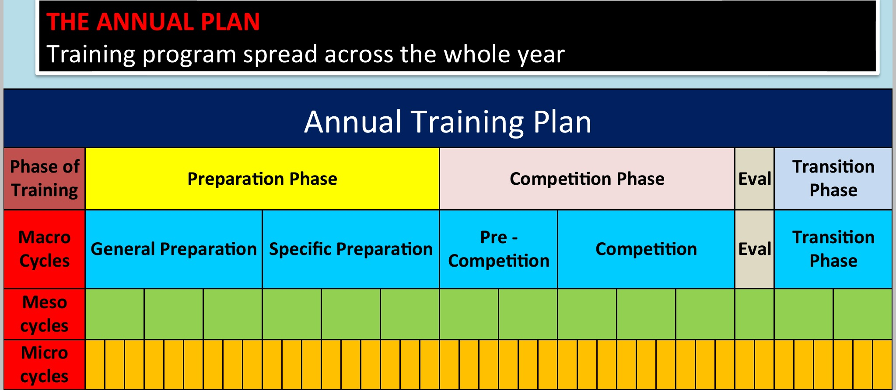
* Involves varying Volume and Intensity of training, if done properly it will:
  + - Help to avoid overtraining and burnout
    - Promote higher levels of enthusiasm
    - Ensure proper application of progressive overload
    - Minimise risks of injury
    - Plans for athlete to peak at the right time
* Phases of am Annual Plan:
  + - Preparation Phase-
      * Lasts about 6-12 weeks
      * General- training designed to improve aerobic base, high volume low intensity
      * Specific- practise of game specific skills, high intensity low volume
    - Competition Phase-
      * Match specific, game play and strategies, Specificity principal is crucial
      * Constant Peaking and Tapering is required for optimal recovery and performance
    - Evaluation Phase-
      * Evaluation of strengths and weaknesses to determine what did and did not work
    - Transition Phase-
      * Training volume and intensity significantly to allow for recovery
      * Aerobic fitness should be maintained to avoid detraining
      * Opportunity for corrective surgery and rehabilitation

Tapering;

* Tapering involves Decreasing the Volume of  training whilst Maintaining or Increasing Intensity an athlete does to allow the body me to recover from the stresses placed on them during training
* Physically it aims to allow full repair of tissue and refuelling of energy stores
* Mentally it aims to get an athlete in their Ideal Performance State
* Usually 4-20 days long, depending on exercise type. Sprint=short taper, marathon=long taper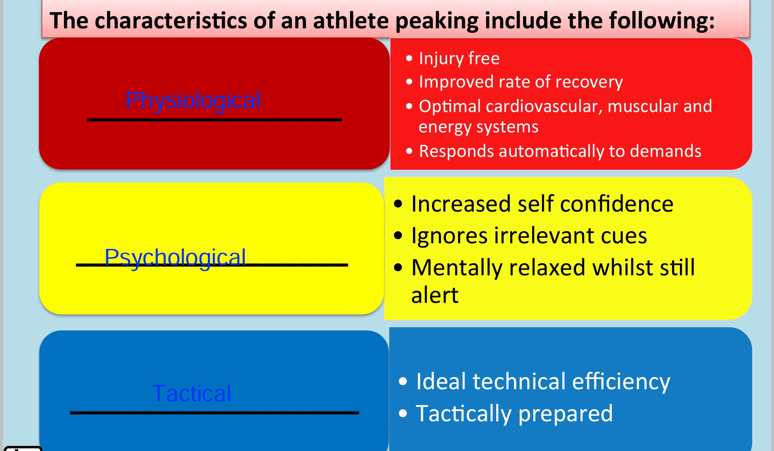
* Strategies used to Taper:
  + - Increase the use of recovery strategies
    - Reduce training volume whilst maintaining or increasing Intensity
    - Individualise the program
    - Monitor diet to ensure the athlete has optimal Glycogen stores

Peaking;

* When an athlete reaches their Ideal Performance State at the correct time
* Peaking at the correct time is due to a well thought out annual plan

Overtraining;

* Occurs when an athlete has been repeatedly stressed by training to the point where the rest periods between exercise bouts are no longer adequate
* As a result, training no longer leads to improved performance
* Causes:
  + - Work load is too high
    - Insufficient application of progressive overload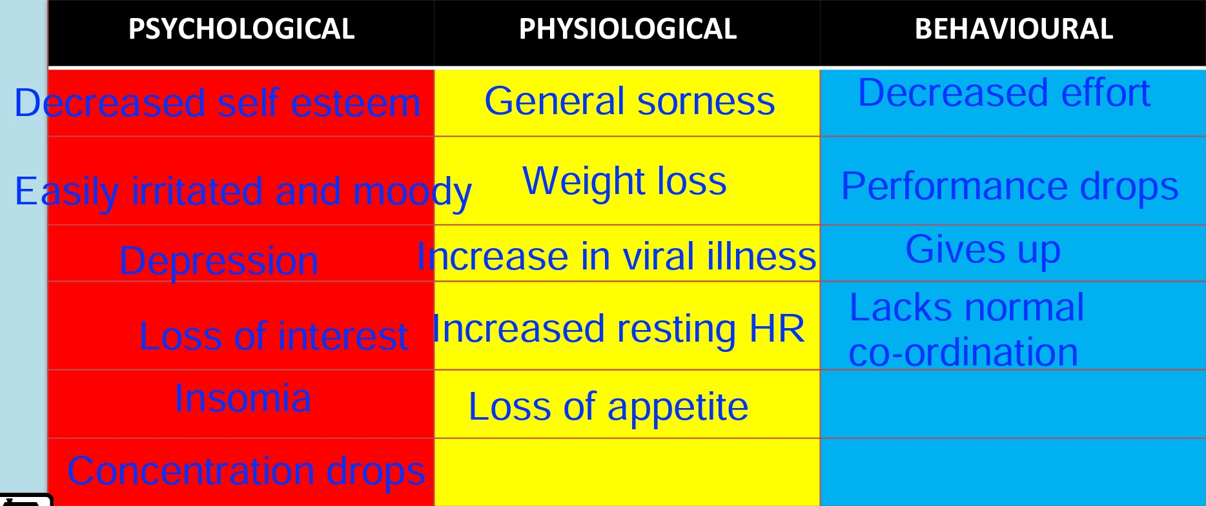
    - Lack of variety in training
* Prevention:
  + - Have well planned training program with sufficient rest periods
    - Individualise training program's
    - Educate players of signs and symptoms of overtraining
    - Train at different venues

Injury Rehab;

* Main idea of rehabilitation is to gradually increase activity of the injured athlete until they are ready to return to play
* 4 Phase Process-
  + - 1. Range of Motion: improve range of motion to 80-90% pre injury motion
    - 2. Endurance: progressively increase activity of muscles, using little to no weight
    - 3. Strength: use a weight bearing program to gradually increase strength of muscles
    - 4. Skill: re-educate muscles to perform sport specific movements